Laverstoke and Freefolk Parish Council
Chairman – Bob Hough, Longhouse, Freefolk, Whitchurch, RG28 7NW 07990 570035
Clerk - Nicky Nicklin, Parish Office, Lady Rose Hall, Laverstoke Lane, Laverstoke, Whitchurch, RG28 7NY
Tel: 07725 368012 laverstokeclerk@gmail.com

Meeting scheduled for Tuesday 14th July 2020 at 7.30pm to be held online. Members of the public are welcome to attend, please contact laverstokeclerk@gmail.com or call 07725 368012 for login details.

7.30pm – 7.45pm Public time
7.45 onwards PC Meeting
- Apologies for absence
- Declarations of interest
- Sign and approve minutes of PC meeting of 9th June 2020
- Parish Councillor vacancy
- Bombay Sapphire update
- Maintenance items
- Car park Freefolk update
- Covid-19 update
- Climate change
- Community Site updates
  - Pavilion
  - Lady Rose Hall incl. Agreement on Lifecycle Analysis, planning for re-opening for hire
  - Courts & archery area incl. WTC request for consideration of tennis court floodlighting
- Finance
  - Finance report for June 20 & items over £100 ex VAT
- Correspondence
  - Daily Dave Burns B&D Cllr updates
  - Action Hampshire – Community Centre guidance
  - Basingstoke District Assoc PCs – Manydown development info
  - B&D Playground team – on reopening the playground
- Planning

Any plans received after 08.07.20

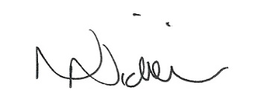

Date of next meeting: 8th Sep – 7.30pm.

08/07/20

