Laverstoke and Freefolk Parish Council
Chairman – Bob Hough, Longhouse, Freefolk, Whitchurch, RG28 7NW 07990 570035
Clerk - Nicky Nicklin, Parish Office, Lady Rose Hall, Laverstoke Lane, Laverstoke, Whitchurch, RG28 7NY
Tel: 07725 368012 laverstokeclerk@gmail.com

Meeting scheduled for Tuesday 11th Feb 2020 at 7.30pm at Lady Rose Hall, Laverstoke Lane, Laverstoke. All members of the public are welcome to attend.

7.30pm – 7.45pm Public time
7.45 onwards PC Meeting
- Apologies for absence
- Declarations of interest
- Sign and approve minutes of PC meeting of 14th Jan 2020
- Maintenance items
- Climate change
- Update on Car Park, Freefolk
- Community Site updates
  - Pavilion incl. Men’s Shed
  - Lady Rose Hall
  - Courts & archery area
- Finance
  - Finance Summary Jan 20 & items over £100 ex VAT
- Correspondence
  - B&D happy with SID cost sharing with Bombay Sapphire
  - HCC newsletter: driving down Hampshire’s carbon footprint
  - HCC Streetlights, confirmation of 6th light front side of Mount pleasant cottages
  - VE Day 75th Anniversary on Bank Hol Friday 8th May

- Planning
  - T/00055/20/TCA Application for works to trees growing in a conservation area: Proposal: chestnut tree: fell. Playground Laverstoke - hHeavily pollarded tree opposite Pavilion)
  - 20/00245/FUL | Increasing the height of both the existing 2m high tennis practice wall and side netting by 0.75m to 2.75m | Tennis Courts Laverstoke Lane Laverstoke Hampshire
Any plans received after 5.02.20

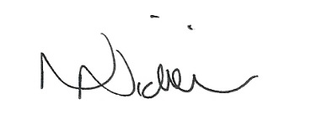

Date of next meeting: 10th March – 7.30pm.

05/02/20

