

Newsletter February 2020!
The month has got off to a good start with the Millennium Green team hosting an enjoyable and successful quiz night. Hardy's Cottage garden plants are planning their opening for the year and have a number of exciting events and talks scheduled that you can attend. Watership Down Inn is looking forward to Valentine's night and has a couple of tables free still, if you are quick! Dog mess has raised it's ugly whiff again and you need to register in order to use the tip. Read on for all this and more.
Hardcopy Newsletter distribution - we are looking for someone with 20-25 minutes to spare per month who can deliver our newsletter in hardcopy to several of our Freefolk residents. It might suit someone who can incorporate it into their dog walk? If you can possibly help please let Nicky know on laverstokeclerk@gmail.com or 07725 368012
You can find a link to the monthly Overton News&Views here.

  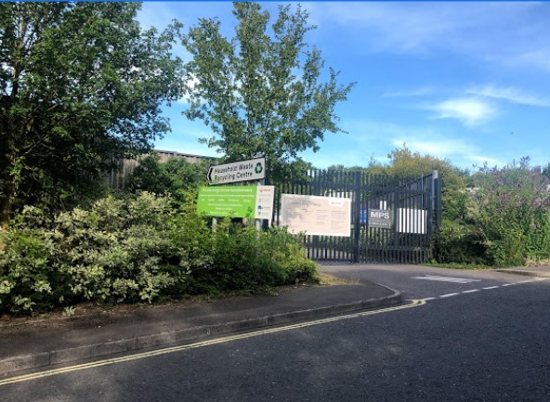
  Have you registered?
  In case you've missed the recent flurry of social media exchanges on the topic of the dump, let us enlighten you. From April this year you will need to be registered as a Hampshire resident to be able to use the Hampshire Waste and Recycling Centres for free. They are trying to ensure the facility which is paid for by Hampshire tax payers is used for the benefit of Hampshire residents. Automatic number plate recognition technology will be used to police this and you can register up to 3 cars or 4x4s. If you visit in a van, pick-up or use a large trailer you will need a commercial vehicle permit.
  People from outside the area may continue to use these tips but at a charge of £5 per entry.
  So make sure you sign up asap and latest end March 2020 or you will be charged on tip usage until you have registered
  For residents without internet call 0300 555 1389 to make your registration.
  Follow this HCC link to register your vehicle and for further information. You simply need to enter the following:
  name
  address
  phone number
  email address
  vehicle registrations
  For details of our nearest tips see:
  Basingstoke Household Waste & Recycling Centre
  Andover Household Waste & Recycling Centre
  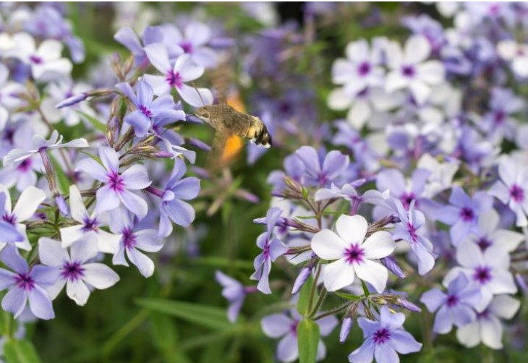
  Hardy's events & opening
  Hardy's are opening officially for 2020 on 1st March and as usual they are hosting a number of interesting talks in the Spring on a variety of topics. The first is one of Rosy Hardy's talks run in partnership with the RHS. It is on spring flowering perennials on 11th March from 14.00 - 16.30. Click here for information/booking
  Next up Rosy is running one of her Propagation Workshops on 18th March at 10.30 - 12.30. She will show you how to collect and store seeds, how to take tip, basal or root cuttings and lots more. See the website for details and how to book your spot.
  Local Garden Designer, Sarah Eberle is also doing a talk on 25th March at 10.30 - 12.30. Her topic is demystifying the design process of creating an RHS Chelsea Gold Medal winning garden and then helping us to translate design concepts into ideas that we can use within our own gardens. See here for details
  And Pelagoniums (Geraniums) are the subject of Heather of Fibrex nursery's talk on 28th April 10.30 - 12.30. Heather runs the national collection and also makes excellent Pellie cakes! Click here for further info.
  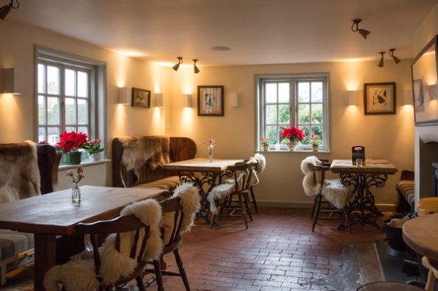
  Watership treat for your Valentine?
  Valentine's Day is just around the corner, our Chef has designed some special dishes to help you celebrate. Don’t forget to reserve your table as soon as possible as we only have a few left.
  Just a reminder, the L&F special offer on accommodation runs through until the 31st March 2020. If you have friends or family needing to stay in the area we are offering you a special 15% discount. Availability can be checked online but to get your special discount just email Nat or Emma on enquiries@watershipdowninn.com and quote L&F special offer.
  We advertised the Fish evening (21st Feb) in the January newsletter and booked the last table this week, based on the popularity we will look to run something similar again soon – watch this space!
  Don’t forget to follow us on Facebook or Instagram for the latest on menu specials, events, promotions...
  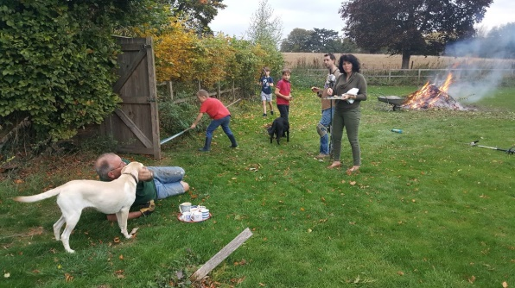
  Village clear up advanced notice: Sunday 19th April
  We're giving plenty of advance notice of the next village clear up. Please keep Sunday 19th April from 13:00 free in your diaries! There are a large number of jobs that we need to do to keep our parish the way we like it! Sweeping bus shelters, cleaning noticeboards, clearing excessive growth from the playground fences, strimming hedges, tidying in the Quiet Garden and kickabout court are just some of the items currently on the list!
  We can achieve so much more with more volunteers. It is also a great way to meet other people in the village and get the kids involved too. Meet beside Lady Rose Hall at 1p.m. with useful tools!
  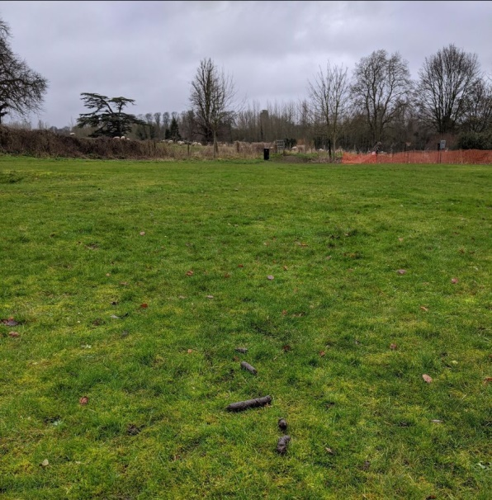
  Beware Fixed Penalty Notice.....!
  Sorry to post this picture... but enough is enough. Failure to pick up dog faeces is an offence subject to a Fixed Penalty Notice with a £50 fine. We've had lots of people comment on social media about the dog mess on the Millennium Green. We've also, with the help of the B&D Community safety team been trying to track down a white van dog walking service which has used the field as a dumping ground for 8 dogs at once!
  Scant regard for poo picking is causing quite an unhealthy and unsightly mess. It may be incomers but we should probably also keep an eye on night time dog walking of multiple dogs and make sure we are not diverted by our telephones at the appropriate moment! We are also looking to move the litter bin in the car park which is currently a little hidden by the charity clothing bin and cars. This will be nearer the Millennium Green entrance. With a bin at two of the three entrances there should be no excuse for not bagging up and using a litter bin! Alternatively take your little parcel home with you! Thank you.
  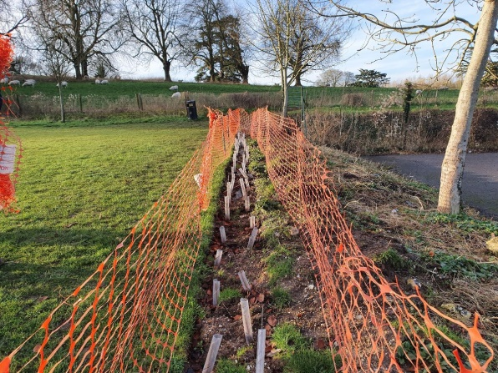
  Other bits'n'pieces
  Please take care as you pass by the new hedge beside the kickabout court so as not to damage the planting. The saplings look a bit twig-like at the moment but we're hopeful that in spring we'll see some nice buds and over time a thriving hedge. The plants are in protective pipes and we have now put out some temporary orange fencing as a reminder. Please ask your offspring to keep their bikes away and also discourage dogs from using them as a little wee spot!
  Please keep cars and sheds secure as we heard mention recently of cash being taken from a car parked in the Lady Rose Hall car park.
  
  London Street closure
  We have had advance notification that London Street/Road (B3400) in Whitchurch will be closed for 3 days anytime within a month of 17th Feb. Actual start date will be dependent on weather etc so expect diversions from the 17th.
  The official diversion is through Overton/Kingsclere road and round Cole Henley Road. The buses will be impacted but I am afraid at time of going to press we are not sure what disruption/changes there'll be. Hopefully we'll have further information nearer the time.
  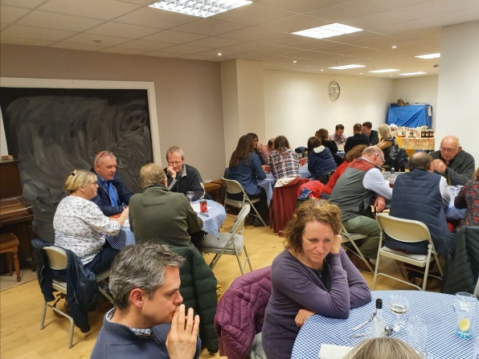
  Quiz night success
  The Millennium Green quiz night took place on Sat 1st Feb in Lady Rose Hall. It was a fantastic event with a great turnout. Quizmaster Colin had yet again managed to pitch some suitably challenging and irksome questions. You can see the concentration in the photo above! Well done to Clare Albert for organising and to all the chilli makers, bar team, clearer uppers and prize doners! Thank you to all those who supported by attending. A terrific £1178 has been raised which will be used towards the maintenance of the Millennium Green spaces in our neighbourhood.

  
  PC Meetings
  Next meeting dates:
  11 Feb
  10 Mar
  14 Apr
  12 May
  Laverstoke and Freefolk PC meetings start at 7.30pm with up to 15 mins public time. Anyone is welcome to attend to ask questions, make suggestions or air views on local issues during the public time. Time will be split equally between the number of people wishing to speak. After public time parishioners are welcome to stay on but they are unable to interrupt the Council meeting. Venue: Lady Rose Hall, Laverstoke Lane. Note: no meeting is held in August.
  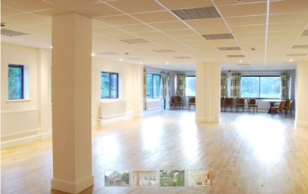
  Lady Rose Hall Class contacts
  Watership Down Nursery: Day nursery offering full child care services
  Contact Will & Lucy Jones on 01256 895504 or
  contact@watershipdownnursery.
  co.uk
  To join BootCamp or Yoga contact:
  Liam on 07879845037 or
  liam@complete-performance.co.uk
  To book the hall for your party or events see
  www.ladyrosehall.co.uk or email
  laverstokeclerk@gmail.com
  
  Continued...
  Our Local Day Care Centre:
  Kingfisher Day Care Centre for Elderly or
  kingfisherdaycentre@gmail.com
  Millennium Green:
  landfreefolkmillenniumgreen
  To Report problem with roads, footpaths & verge
  Hantsweb
  To report trees on roads:
  0300 555 1388
  Contacts
  L'stoke and Freefolk Facebook
  laverstokeandfreefolk.org.uk
  Nicky Nicklin, Parish Clerk: Tel. 07725 368012 email:
  laverstokeclerk@gmail.com
  Bob Hough, PC Chairman: Tel. 07990 570035 email:
  laverstokeclerk@gmail.com
  Newsletter:
  laverstokeclerk@gmail.com
  Lady Rose Hall:
  www.ladyrosehall.co.uk
  Bombay Sapphire Resident's
  Help Line: 01256 890078
  (Also use to alert BS security you are collecting Defibrillator).
  Our neighbouring web-sites:
  The Official Whitchurch web site
  The Original Whitchurch web site
  Overton Parish Council web site
  Our Local Sports Clubs
  Whitchurch Tennis Club
  Overton Black Arrows Archery Club
  Overton Rugby Club

Copyright © Laverstoke and Freefolk Parish Council 2020
Our mailing address is:
Laverstoke and Freefolk Parish Council Newsletter
Lady Rose Hall
Laverstoke Lane
Whitchurch
RG28 7NY

