Laverstoke and Freefolk Parish Council
Chairman – Bob Hough, Longhouse, Freefolk, Whitchurch, RG28 7NW 07990 570035
Clerk - Nicky Nicklin, Parish Office, Lady Rose Hall, Laverstoke Lane, Laverstoke, Whitchurch, RG28 7NY
Tel: 07725 368012 laverstokeclerk@gmail.com

Meeting scheduled for Tuesday 14th Jan 2020 at 7.30pm at Lady Rose Hall, Laverstoke Lane, Laverstoke. All members of the public are welcome to attend.

7.30pm – 7.45pm Public time
7.45 onwards PC Meeting
- Apologies for absence
- Declarations of interest
- Sign and approve minutes of PC meeting of 10th Dec 2019
- Bombay Sapphire Update
- Maintenance items
- Climate change
- Community Site updates
  - Pavilion incl. Men’s Shed
  - Lady Rose Hall
  - Courts & archery area
- Finance
  - Finance Summary Dec 19 & items over £100 ex VAT
  - Finalise FY2020/21 budget
  - Agree FY2020/21 Precept
- Correspondence
  - Woodland Trust response to our enquiry re Tree Packs for Residents
  - B&D have set Council Tax base
  - SID support from Bombay Sapphire
  - Improving SW rail

- Planning
  - 19/03162/HSE & 19/03163/LBC: Old Rectory, Freefolk - Conversion of 2 outbuildings, erection of single storey extension, demolition of stables & construction of swimming pool.
  - 19/03072/RET: Watership down Inn Removal of condition 16 of 15/013134/FUL to allow retention of existing buildings for storage
  - Any plans received after 8.01.20

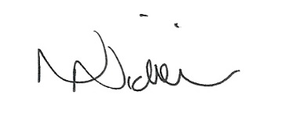

Date of next meeting: 11th Feb 20 – 7.30pm.

08/01/20

