Laverstoke and Freefolk Parish Council
Chairperson – Bob Hough, Longhouse, Freefolk, Whitchurch, RG28 7NW 07990 570035
Clerk - Nicky Nicklin, Parish Office, Lady Rose Hall, Laverstoke Lane, Laverstoke, Whitchurch, RG28 7NY
Tel: 07563 942360 laverstokeclerk@gmail.com

Meeting scheduled for Tuesday 12th Jan 2015 at 7.30pm at Lady Rose Hall, Laverstoke Lane, Laverstoke. All members of the public are welcome to attend.

7.30pm – 7.45pm Public time
7.45pm onwards PC Meeting
- Apologies for Absence
- Declarations of Interest
- Sign and approve minutes full PC meeting 15th Dec
- Bombay Sapphire update
- BT Broadband
- Maintenance including village clear up dates
- Traffic Speed
- Community Site
  - Usage of Pavilion
  - Usage of Lady Rose Hall
  - Tennis Courts
- Finance
  - Finance Summary Dec 15
  - Grant Applications
  - Precept calculator review
- Correspondence
LRH Utility contract review & decision
- Planning
Any plans received between 06/01/16 and 14/01/16

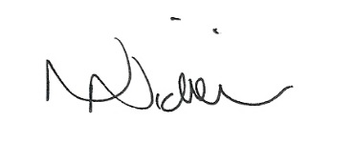
Date of next meeting 9 ^{th} Feb 16 – 7.30pm 6/01/16

