Laverstoke and Freefolk Parish Council
Chairperson – Bob Hough, Longhouse, Freefolk, Whitchurch, RG28 7NW 07990 570035
Clerk - Nicky Nicklin, Parish Office, Lady Rose Hall, Laverstoke Lane, Laverstoke, Whitchurch, RG28 7NY
Tel: 07563 942360 laverstokeclerk@gmail.com

Meeting scheduled for Tuesday 13th Oct 2015 at 7.30pm at Lady Rose Hall, Laverstoke Lane, Laverstoke. All members of the public are welcome to attend.

7.30pm – 7.45pm Public time
7.45pm onwards PC Meeting
- Apologies for Absence
- Sign and approve minutes full PC meeting 8th Sept
- Bombay Sapphire update
- BT Broadband
- Car Parking at Freefolk
- Maintenance including Village Clear Up 17th Oct
- Playground Update
- Traffic Speed
- Community Site
  - Usage of Pavilion – Men’s Shed
  - Usage of Lady Rose Hall – Nursery Licence
  - Tennis court usage
  - Insurance renewal approval
- Grant applications – Millennium Green
- Finance
  - Finance Summary Sept-Oct 2015
- Correspondence
  - De La Rue re Buildings insurance
- Planning
15/03134/FUL: The Watership Down Inn, Freefolk, erection of detached 4 guest room building
15/03360/HSE: 23 Laverstoke Lane, Laverstoke, erection of single storey rear extension

Any plans received between 07/10/15 and 13/10/15
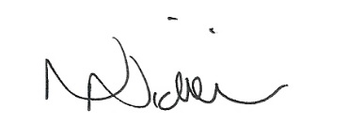

Date of next meeting 10th Nov 15 – 7.30pm 7/10/15

