Laverstoke and Freefolk Parish Council
Chairperson – Bob Hough, Longhouse, Freefolk, Whitchurch, RG28 7NW 07990 570035
Clerk - Nicky Nicklin, Parish Office, Lady Rose Hall, Laverstoke Lane, Laverstoke, Whitchurch, RG28 7NY
Tel: 07563 942360 laverstokeclerk@gmail.com

Finance Committee Meeting scheduled for Tuesday 24th Nov 2015 at 7.30pm at Lady Rose Hall, Laverstoke Lane, Laverstoke. All members of the public are welcome to attend.

7.30pm Public time
7.40pm Committee Meeting

- Apologies for Absence
- Terms of reference: recommendation to PC
- Financial policies
- Financial reporting and long term planning
- Update on current financial position of PC
- Potential projects and grants
- Precept planning

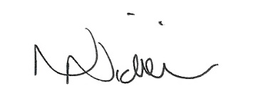
Date of next Full PC meeting 15th Dec 15 – 7.30pm 18/11/15

